

Initial Idea Paper

Project Title:

A PC Software for 3D Face Reconstruction mapping into Game Model

LEI RUIJIA 1709853U-I011-0012

WANG HAOXU 1709853J-I011-0165

XU TIANHAO 1709853J-I011-0223

YUE ZHAOKE 1790853U-I011-0066

# Instructor professor: Subrota Mondal

**Project Title:**  A PC Software for 3D Face Reconstruction mapping into Game Model

**Group Information:**

LEI RUIJIA 1709853U-I011-0012 1709853ui011001@student.must.edu.mo

WANG HAOXU 1709853E-I011-0032 1026839618@qq.com

YUE ZHAOKE 1790853U-I011-0066 yzk9950218@gmail.com

XU TIANHAO 1709853J-I011-0223 573152970@qq.com

**Programming languages:**

Python, 3D max script, C++

**1. Introduction**

In view of the emergence of several popular face-swapping softwares about few months ago, plus it can’t be neglected that with the development of technology, users in this internet age are more and more interested in customized products. More and more people are interested in exploring and using things that can be related to their own characteristics, rather than those pre-defined components by developers. Thus, after the observation of cutting-edge AI technology and drastic brainstorming our group hit upon the idea of applying specific target face no matter users’ own faces, the faces of good friends, or even the faces of celebrities. In order to match the imagination of customers that replacing the faces of the characters in games (almost including the face, stature, emotion with facial expression) and to improve the enjoyment and experience of users. We want to make a software to make it convenient for users to get their 3D face model and can actually see their faces come into games.

Through our efforts, we finally got in touch with a game company (because we used to love playing with their product) and were allowed to use some of their character models and their game engine editor to help us achieve our goal.

**2. Expected List of Features**

Video import

Extract video into single picture per frame

3D face model reconstruction by specific video

Face model mapping

Generating animated effect on character model (face replacement and facial movement)

1. **Market and Demand Survey**

Local APPs like *FaceU, B612, Snow* and *ZAO* which mainly focus on the beauty function of photography and video recording have been widely used and this kind of apps are most mobile software. Moreover, there are many face-swapping apps, too. Almost those softwares focus on the 2D effect level. However, little of those softwares can do something for games, not to mention constructing a 3D face model, we find that relevant software is still scarce in the field we are considering. It means the work we do is meaningful.

We made an online questionnaire to find out what people thought of our software and whether they were interested in it or they have the demand or not.

The statistical result is shown as following (57 participants):

**#Do you interested in our project?** **#Do you have demand to use software like this?**

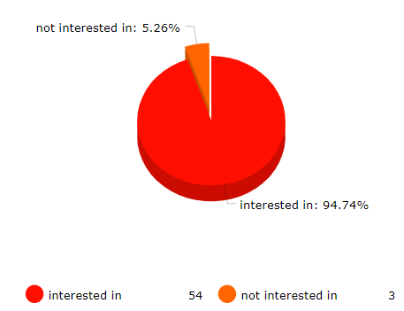 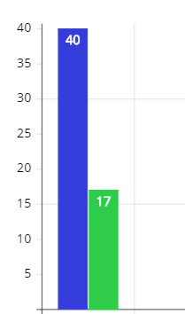

1. **Risk Analysis**

For analyzing risk of our application, due to the software needs a lot of computing and using neural network with AI technology, the first thing comes to my mind is that it will take much time if the import video is too long, this requires patience, thus may reduce users’ favorability and make it not so easy to do some experience optimization. As what is aforementioned, I think the high requirements for computer system memory and computing capability is also a potential risk.

1. **References**
2. Accurate 3D Face Reconstruction with Weakly-Supervised Learning: From Single Image to Image Set from <https://arxiv.org/abs/1903.08527>
3. Face Alignment in Full Pose Range: A 3D Total Solution

from <https://arxiv.org/abs/1804.01005>

1. How far are we from solving the 2D 3D Face Alignment problem (and a dataset of 230,000 3D facial landmarks) from <https://openaccess.thecvf.com/content_ICCV_2017/papers/Bulat_How_Far_Are_ICCV_2017_paper.pdf>
2. Joint 3D Face Reconstruction and Dense Face Alignment from A Single Image with 2D-Assisted Self-Supervised Learning from <https://arxiv.org/abs/1903.09359>
3. Game company <https://www.xishanju.com/> -> game page <https://jx3.xoyo.com/>

6.